Novious Global Co. Ltd

Logo options: (1) Letter -based design, (2) Symbol/shape-based design. We are open to explore & consider any other creative options too.. I’ve created few using AI, I personally like the red on

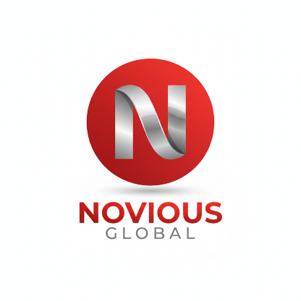

Design theme color combination across web. [Please move the design near to this color combinations this is also similar to the picture I share with u] : https://www.dragonsourcing.com/services/
Reference for web content； https://jingsourcing.com/
https://leelinesourcing.com/
Mape: https://www.thadaniinternationaltrading.com/?fbclid=PAZXh0bgNhZW0CMTEAAacY9SAlpsNvgQSPdisxaCxw_ES7cIoPj--r4Wd9iGjHdPBxxjygEvNFcpqNAQ_aem_CZs7NlYvLQxf9pvHlF3JQw
https://www.cmsourcingshipping.com/

https://tinasourcing.com/

Website design & content requirements
1- Home page

Intro / Hero Section
Headline: Your trusted sourcing partner from China
We Make Things Easier for you by Finding a reliable supplier and ensuring smooth production and delivery. Our team manages every step, from product selection and supplier verification to on-time delivery.
Novious Global is group of experts which helps in connecting international buyers with reliable Chinese manufacturers and help them in buying their desired products. We offer one-stop solutions for sourcing suppliers, startups, e-commerce seller, retail chains, mobile accessory stores, fashion & lifestyle brands, furniture & home décor businesses and a wholesalers or a global brand, we help you find the right product, ensure quality, and deliver them to your doorstep with complete peace of mind.
We are a reliable sourcing and supply chain partner based in China, helping businesses worldwide access high-quality products at competitive prices. With a strong network of manufacturers, professional sourcing experts, and hands-on project management, we simplify the entire process from product discovery to final delivery.
Your success is our success! / We Win When You Win.”
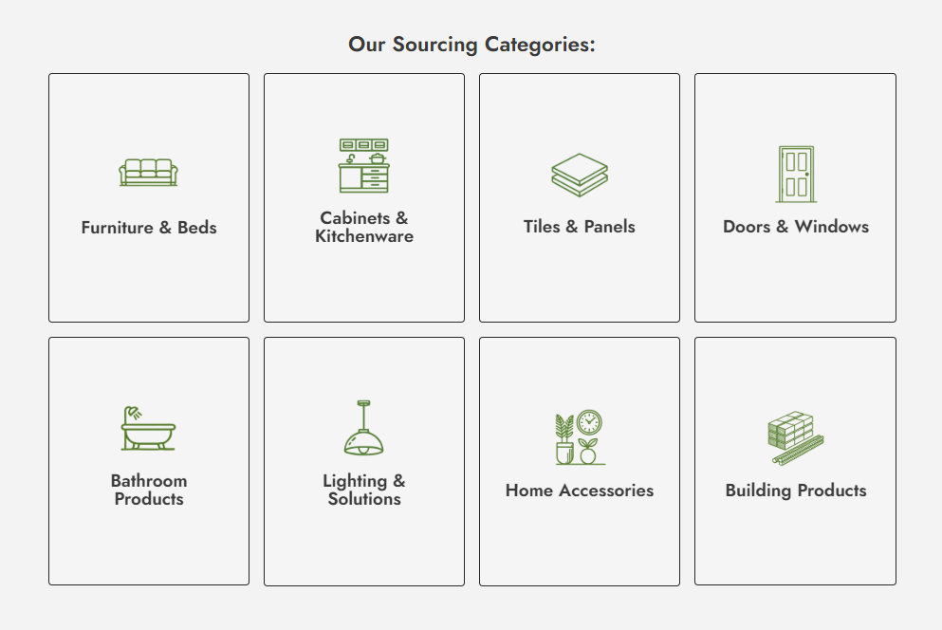

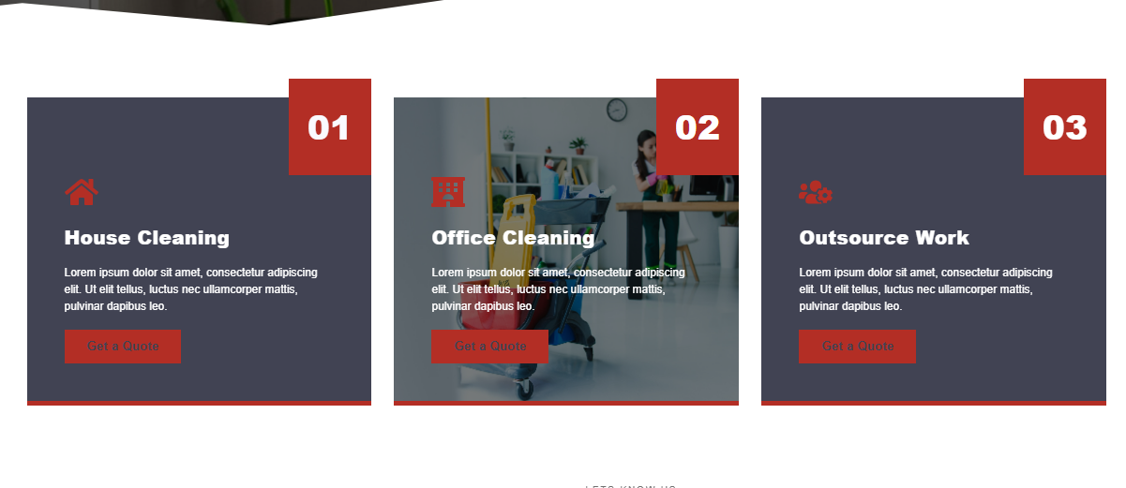
Trusted by over 1500 Customers
Responsiveness
Risk free Sourcing No hidden fee

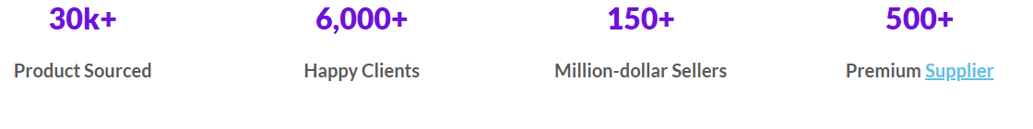
What We Do

- Product Sourcing
- Factory Visit
- Supplier Verification & Audits (ensures supplier legitimacy, background checks)
- Private Label & Packaging
- Quality Control & Inspection
- Negotiation & Contract Support (help in cooperation and agreement with suppliers)
- Sample Procurement & Evaluation (ordering and checking samples before bulk order)
- Amazon FBA Solutions (labeling, prep, forwarding, compliance)
- E-commerce Fulfillment Support (Shopify, eBay, Walmart, etc.)
- Global Shipping & Logistics (air, sea, express, customs clearance)
- Market Research & Trend Analysis
- After-Sales

Partners
3
2
1

YouTube Video Link

2- Products Preview (Clickable Categories something like below in image)
（4-6 Images of different products from each category and a short product description）
Products category preview
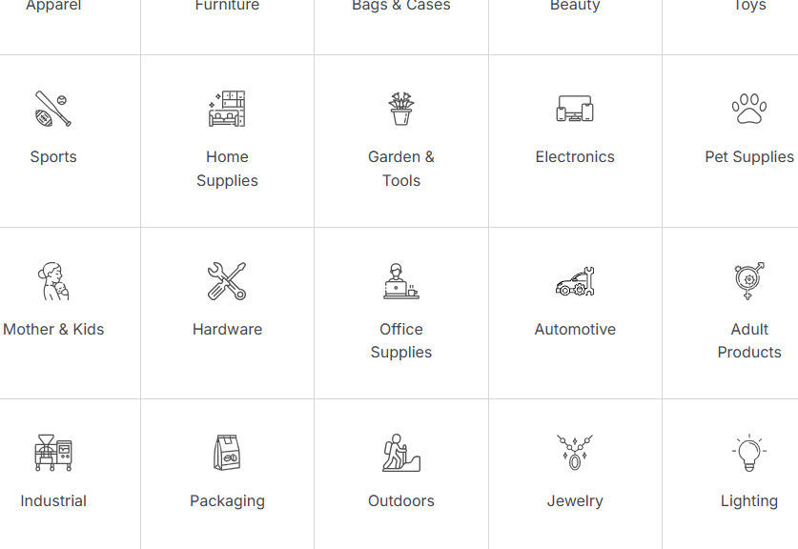

Products Content: Follow (https://jingsourcing.com/our-products/)
1-Clothing, Textile & Fashion Accessories
Trendy apparel, scarves, hats, and fashion add-ons sourced from top Chinese suppliers customized to meet your market demand.
Whether you want stock or customized products, we can offer them.

1.1 Apparel
China produces almost 60% of clothes in the world Jacket Supplier Sportswear, Stage clothing, workers uniform, Leader jeans, and stylish jackets for both male and females. Vests, Undershirts and tops, Sweaters and hoodies, skirts, jeans, T-shirts
We also offer different kinds of clothing in stock at factory-direct prices.
1.2 Baby & Kid’s Products
Safe and reliable children’s clothing, educational toys, and accessories—all compliant with international safety standards
Padel Kids short sleeve T-shirt, Children's clothing sets
Autumn cotton long-sleeve, Summer slip dress
Winter children's down jacket autumn jacket, Brand children's clothing factory

1.3 Accessories
We help you wholesale and customize all kinds of clothing accessories, like gloves, hats, belts, scarves, watches, sunglasses, ties, pins, belts, etc. Tell us what you need if you can’t find them in the list.
Glasses, watches,

1.4 Undergarments
We’re experienced in producing and designing types of undergarments in diverse fabrics. No matter seamless fabric, daily wear, or sexy style, we help you wholesale or customize any you want.

1.5 Socks
We help you find several sock factories even with a low MOQ (only $500). You can get the latest styles like traditional knitted styles or custom 3D-printed ones from us.

2-Shoes & Watches
Affordable yet stylish footwear and watches that blend design, comfort, and functionality.

2.1 Shoes
Zhejiang is one of the shoe manufacturing centers in China. We’ve sourced a wide range of fashion shoes like casual shoes, kids’ shoes, boots, and shoe accessories.

2.2 Watches

3- Jewellery
From fine jewelry to everyday wearables, we connect you with trusted manufacturers for high-quality, stylish collections.
Ring, silk gloves Shiny fashionable trend earrings
Necklace, golden chain, stone inlay from pearl European style
With 10+ years of experience in the jewelry business, we’ve got over 35 jewelry factories with long-term cooperation. We help create brand-new designs or improve existing styles as per your needs.
Bags & Cases
Handbags, backpacks, suitcases, and protective cases designed with durability and modern fashion trends in mind.
Kitchen
Cookware, utensils, and innovative kitchen gadgets that bring convenience and quality to households worldwide.
Bathroom
Towels, storage solutions, shower accessories, and bathroom essentials crafted for daily comfort.
Home Décor & Accessories
Decorative pieces, wall art, lighting accents, and household accessories to add style to every living space.
Furniture
Indoor and outdoor furniture—modern, functional, and customizable for your market requirements.
Sports & Entertainment
Sporting goods, outdoor gear, and entertainment products sourced from verified suppliers.
Lights & Lighting
LED lighting, decorative fixtures, and smart solutions to brighten every environment.
Electronics & Batteries
Consumer electronics, mobile accessories, and reliable battery solutions tested for safety and efficiency. Surveillance cameras, ultrasound, thermometers, lab equipment, EVs, scooters, lithium batteries, BMS, charger’s Solar panels, PV cells, inverters, solar kits
Hardware Tools
Hand tools, power tools, and DIY kits for both industrial and household use. Industrial Machinery / Machine Tools Hand Tools (Screwdrivers, Hammers, Wrenches, PVC Fittings), Hand drills, saws, wrenches, hammers
Toys

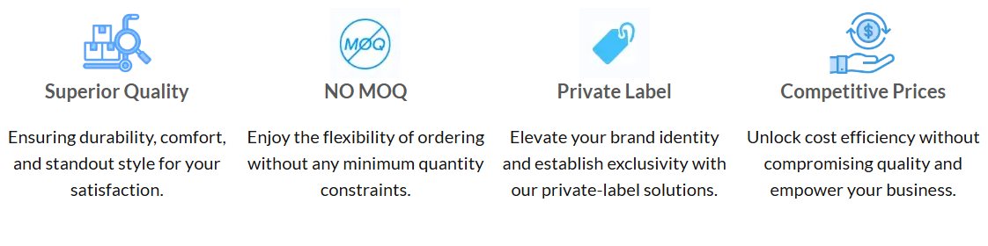
3- Solution
- Product sourcing (https://jingsourcing.com/pricing/)
Product Sourcing
We find the most reliable manufacturers for your needs—balancing price, quality, and delivery time. (Similar to JingSourcing Pricing)
Private Label & Packaging Solutions
We help you customize your products with branding, packaging design, and labeling to stand out in your market.
Fast & Secure Global Shipping
From express courier to sea freight, we handle the logistics to deliver your products safely, cost-effectively, and on time.
Amazon FBA Solutions
Specialized support for Amazon sellers: direct delivery to Amazon warehouses, packaging compliance, and product preparation.
Quality Control & Inspection
Every order is checked before shipment—covering raw materials, production process, and final inspection to ensure top quality.

4- Our services (https://foreasyhome.com/how-we-work/)
1- Souring similar to this page (https://worryfree360.com/one-stop-sourcing/)
One-Stop Sourcing
We simplify the complexity of global trade. From finding suppliers and negotiating prices to managing quality and logistics, Novious Global provides an end-to-end sourcing service.
Supplier Verification
We supplier/manufacturer visits, meeting, negotiation, product quality inspections, certifications checks, and supplier background verification to minimize risks.
Product Development Support
Need a unique design or private label? We help in private labeling and assists in product development, customization and prototyping.
Warehousing & Consolidation
Short-term storage and consolidation services for multiple orders before shipment.
Trade Show & Market Guidance
We actively participate in China and global trade fairs and exhibitions, providing first-hand access to emerging products.

5-Project Base Service

Your Trusted Ambassador in China — Building Partnerships That Last

Introduction
We provide end-to-end project-based services for international corporations and investors seeking reliable partnerships in China. Whether you are wishing to pursue long-term cooperation or short-term contracts, we help you connect, negotiate, and build successful relationships with the right partners. With deep market knowledge, a trusted network, and proven experience, we make complex projects simple, seamless and efficient.

Project Categories
We can assist you in a wide variety of projects, including:
- Energy Solutions: Solar power plants, wind farms, hydro projects, and EV charging station networks.
- Infrastructure Development: Roads, bridges, industrial complexes, and urban facilities.
- Sports & Recreational Facilities: Padel courts, football fields, gyms, and swimming pools.
- Specialized Industrial Projects: Factories machines, equipment’s, warehouses, technology parks.
- Electronics and Machinery: Electric bike, Motor bike Flood lights, etc.
- Telecom
- Medical & Hospital Equipment

How We Add Value
Our strength lies in bridging international businesses with trusted Chinese companies through:
- Product & Supplier Sourcing connecting you with the right partners for your project.
- Supplier Management by ensuring reliable cooperation with vetted and verified companies.
- Construction & Project Support by coordinating local execution while aligning with global standards.
- Quality Control & Inspection Safeguarding project quality through rigorous checks.
- Logistics & Global Shipping by managing transport, customs, and timely delivery.
- Project Supervision by overseeing milestones to ensure smooth execution and accountability.

How it works:
We begin with a brief consultation to understand your objectives, whether it’s a strategic partnership, cooperation, or appointing an exclusive sales partner. From there, we help identify the right partner, arrange meetings, assist with negotiations and translations, formalize agreements, and provide ongoing support throughout the buying process

- Consultation Understanding your project goals and requirements.
- Partner Identification Leveraging our network, and capability to connect you with the right companies in China.
- Negotiation & Agreement Supporting you in establishing fair, transparent, and secure contracts.
- Execution & Oversight Coordinating suppliers, logistics, and construction activities.
- Delivery & Ongoing Support Ensuring your project is completed successfully, with post-project assistance available.

Why Choose Us
- Extensive Network in China as we have access to reliable companies across multiple industries, with full understanding Chinese business environment.
- End-to-End Solutions from sourcing and agreements to logistics and supervision, we cover the entire process.
- Proven Experience and expertise in handling diverse, complex projects for international clients.
- Trustworthy Partner A client-first approach built on transparency, accountability, and long-term cooperation.

6-Blog

7- About Us:
(https://worryfree360.com/about-us/)
Employees/ office/ exhibition/etc

7- Contacts
Head Office
Lotus Tower, No. 159 Tianzhou Road, Shanghai 200032, China (Network Map)
📧 Email: info@noviousglobal.com
📞 Phone: +86 15618483542
WhatsApp: +923077433743

